#include <iostream>

using namespace std;

int getChoice();

bool validateChoice(int);

void getNumbers(int&, int&); // by reference

int addition(int, int);

int subtraction(int, int);

void displayResult(int); // implied

int main()

{

int my_num1, my_num2, choice, my_result;

do {

choice = getChoice(); /// initiazed here

if (!validateChoice(choice)) {

cout << "\nInvlaid choice of the operation. Try again" << endl;

}

} while (!validateChoice(choice));

getNumbers(my_num1, my_num2);

my_result = (choice == 1 ? addition(my_num1, my_num2) :

subtraction(my_num1, my_num2));

displayResult(my_result);

cout << endl;

system("pause");

return 0;

}

/********************************************************/

int getChoice()

{

int choice;// local variable

cout << "Enter your choice, 1 for Addition, 2 for Subtraction:";

cin >> choice; // initialize choice

return choice;

}

/********************************************************/

bool validateChoice(int choice)

{

return (choice == 1 || choice == 2);

}

/********************************************************/

void getNumbers(int& num1, int& num2) // defined function by reference

{

cout << "Enter first number:";

cin >> num1;

cout << "Enter second number:";

cin >> num2;

}

/********************************************************/

int addition(int num1, int num2)

{

return num1 + num2;

}

/********************************************************/

int subtraction(int num1, int num2)

{

return num1 - num2;

}

void displayResult(int result)

{

cout << "\nThe result of the operation is: " << result << endl;

}

VS Input

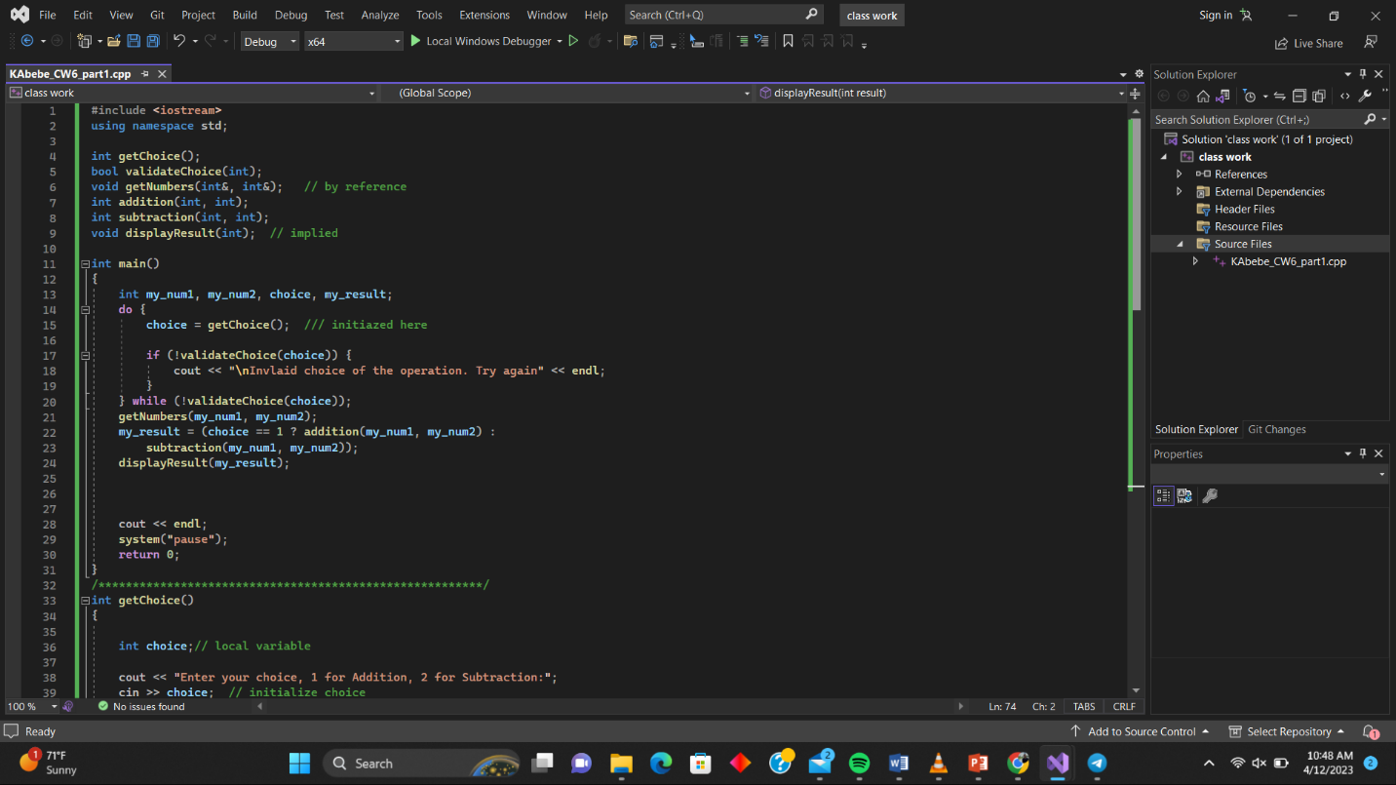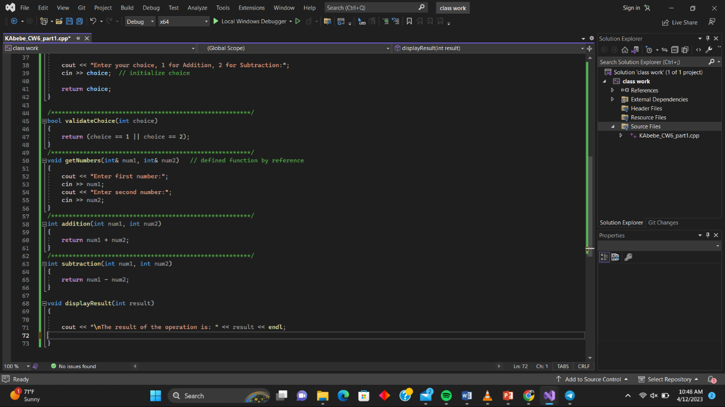

Console Output

